Endpoint Data Loss Prevention

Table of Content
Ch.No | Title | Page No.
1 | Abstract | 2
2 | Introduction | 3
3 | Literature Survey/Research | 6
4 | Methodology | 16
5 | Purposed Work | 42
6 | Diagram {UML} | 45
7 | Time line chart | 46
8 | Future Work | 47
9 | Conclusion | 48
10 | References | 49

1.Abstract
DLP stands for Data Loss Prevention, it includes methods and technologies that serve to prevent the loss, theft, or careless handling of sensitive information. Some of these include encryption, access controls and monitoring. Data can be stolen through various vectors. These vectors can be Endpoint, Cloud, Network, USB’s, etc. therefore, all these vectors need to be properly synchronized with each other so that a clear distinction can be made between the genuine use of the data and its exfiltration in order to ensure business continuity. There are different aspects of data as well, Data-in-use, Data-in-motion, Data-at-rest. Different tools and technologies work simultaneously to make sure that data flow is not interrupted as well as security is enforced. The purpose behind DLP is to make sure that sensitive data does not get compromised, ‘even in its in use or shared form’ within or outside the organization. DLP includes a combination of technical measures and policies that prevent data leakage, including encryption, access control, monitoring and auditing, and data classification. Several DLP approaches can be adopted throughout the life cycle of data usage such as during its creation, storage, transmission, or even access with an aim of safeguarding sensitive data at each point of its usage.

Objective
The focus of the data loss prevention (DLP) project is the development of a complete and workable dataum security architecture which prevents any sensitive information from being inappropriately encountered, displaced or misplaced or breached. This includes an understanding of the essential data properties, having good security practice, and creating data sense of ownership among the employees. The project aims to strengthen the level of the organization’s protection against emerging data risks through effective prevention, averting and counter-measure means. The overriding objective is to maintain the data’s authenticity, confidentiality, and availability in adhering to the required legal and policy framework so as to reduce risks while earning the trust of stakeholders.

Scope/ Limitations of the project
The limitations of the data loss prevention (DLP) project include current practices in data management analysis, data mapping of sensitive data in different repositories, and deploying tools for DLP to data in use or in transit. The project shall include formulation of data handling procedures and policies, training employees on the same, and developing data breach response measures. Also, the objective includes periodic reviews and modifications to keep up with the changes in industry standards and new challenges. The purpose of the project is to embed DLP mechanisms into the security of the corporate IT complex in order to control and reduce the level of data loss and promote the idea of data safety in the organization.

2.Introduction
DLP (Data Loss Prevention) is an application of technological installations and management policies that protect sensitive information from breaches. The main purpose of DLP is to protect important data such as health care, finances, and business data from being accessed by unintended users. DLP solutions usually include several policies, processes, and software tools that attempt to mitigate data loss, leakage, or theft. Such solutions may include the following:
1. Data loss prevention software: solutions that allows individuals and organizations to find sensitive data and categorize it based on the data sensitivity.
2. Management policies on data access: access limitations to sensitive data to authorized persons only.
3. Encryption technologies: Information encoded in transit or rest is less likely to be accessed by outside parties.
4. Data leakage prevention: Data loss events monitoring and notifying system administrators of suspicious events related to data breach.
5. Security of endpoint systems: See that the computer peripherals polite mobiles are not compromised thus loss of data.
6. Awareness creation: Employees need to be trained in data security and measures of preventing data across the organization.
But we focus on mainly DLP software’s and Management policies on data access controls.
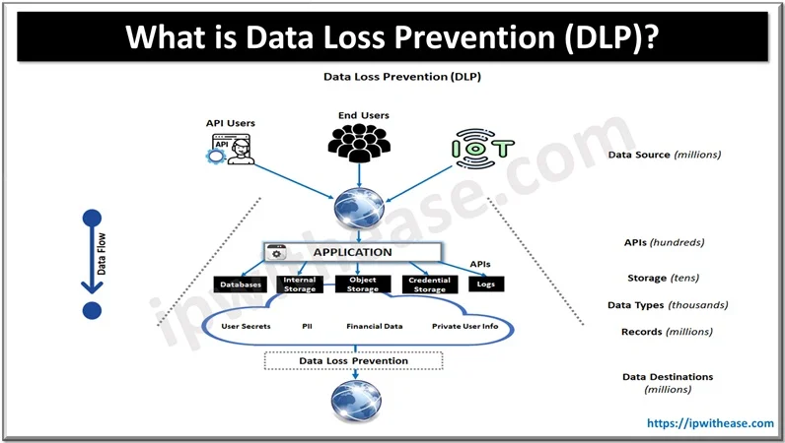

DLP strategies are beneficial for the organizations as they can help to lower the chances of data loss, preserve the brand’s reputation and abide by the data protection laws. As defined by Yadollah Zadeh and co-authors, Continuous security control validation, or simply CSCV, serves as an additional tool in service security – the constant monitoring, testing, and verification of the already implemented security measures within the organization. Such an approach helps organizations anticipate and prepare for changing environments which possess security risk and also helps assess how well an organization’s security measures are performing. These tools can simulate a wide variety of realistic attacks to analyze how effective a given set of controls would stand against them. These tests can further be used to assess security gaps and the level of risk posed across security controls to guide the remediation process. Moreover, as organizations constantly conduct security tests, breaches will be minimized as well as any threats when they occur will hardly have any impact on the organization. In this context, a continuous security control validation method can be focused to the DLP tools allowing the organization to cover their encryption in great depth responsibility larger coverage of customizable scenarios augmented by different file formats.
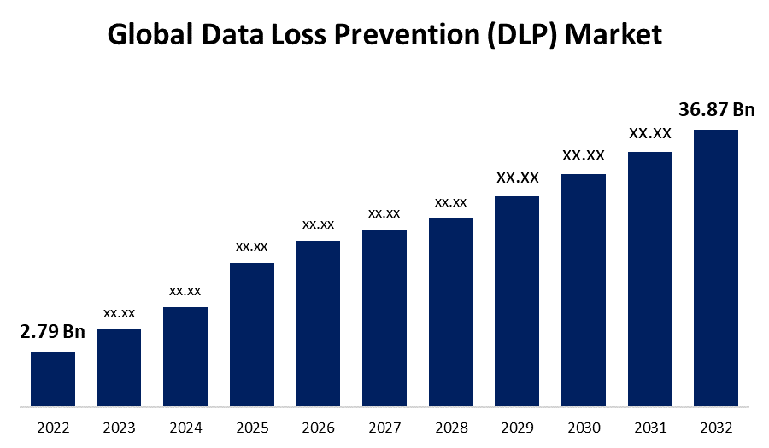

3. Literature Survey/Research
1. Data Security and Privacy-Preserving in Edge Computing Paradigm: Survey and Open Issues
Author’s: Jiale Zhang, Bing Chen, Yanchao Zhao, Xiang Cheng, Feng Hu
Review: This paper explores the facts protection and privateness demanding situations in side computing, pushed by way of the surge of Internet of Things (IoT) gadgets. It highlights the limitations of conventional cloud computing and offers facet computing as an answer. The study affords an outline of aspect computing's definition, architecture, and programs, followed by way of an evaluation of safety threats and shielding mechanisms. It summarizes cryptographic technologies addressing those troubles and reviews current security answers in facet-associated paradigms. Finally, the paper identifies open studies instructions for boosting data safety and privacy in edge computing.

2. EU General Data Protection Regulation: Changes and implications for personal data collecting companies
Author’s: Christina Tikkinen-Piri, Anna Rohunen, Jouni Markkula
Review: This have a look at examines the General Data Protection Regulation (GDPR), with the intention to take effect in May 2018, and its implications for agencies coping with non-public statistics. It contrasts the GDPR with the preceding Data Protection Directive ninety five/46/EC, highlighting key changes and their sensible relevance. The examine emphasizes the need for groups to put together for the GDPR's necessities, which necessitate massive economic and human resources, as well as employee training. A framework is advanced, outlining 12 key aspects of the GDPR's implications for business techniques, organizational practices, and technical measures, supplying steerage for powerful compliance and version.

3. A survey on data leakage prevention systems
Author’s: Sultan Alneyadi, Elankayer Sithirasenan,
Vallipuram Muthukkumarasamy
Review: This examine addresses the developing subject of information leakage and the inadequacies of traditional security measures like firewalls and intrusion detection structures. It introduces Data Leakage Prevention Systems (DLPSs) as proactive solutions designed to stumble on and prevent the unauthorized disclosure of exclusive data in numerous states. The survey affords a clean definition of DLPSs, categorizes current research instructions, and identifies their strengths and weaknesses. Additionally, it highlights the need for more consistent DLPSs and shows destiny studies avenues to enhance their effectiveness. This paintings serves as a treasured reference for both teachers and industry specialists within the discipline of information safety.

4. Data and Information Leakage Prevention Within the Scope of Information Security
Author’s: Barbara Hauer
Review: This paper examines the inadequacies of modern-day employer content material-aware facts leakage prevention (DLP) solutions in reliably shielding information belongings, specially in light of numerous records breaches suggested in 2014. It argues that many incidents fall out of doors the focus of existing DLP systems and gives advanced standards for better characterizing facts leakage incidents. The look at emphasizes the significance of non-technological elements, specially the human element, in statistics breaches. It proposes a comprehensive concept for reinforcing DLP and facts leakage prevention (ILP) techniques within facts security (IS), highlighting the need for a proactive technique and progressed measures to mitigate dangers.

5. A review of the past, present and future of the European loss prevention and safety promotion in the process industries
Author’s: Eddy De Rademaeker, Georg Suter, Hans J. Pasman, Bruno Fabiano
Review: The European Federation of Chemical Engineering (EFCE) marks its 60th anniversary in 2013, celebrating its position in fostering scientific collaboration among engineers and scientists across Europe. The Loss Prevention Symposium collection, organized via the EFCE's Loss Prevention Working Party, has a rich forty-12 months lifestyle of accumulating professionals to speak about advancements in safety and danger control within the chemical industry. This paper evaluations the history and evolution of loss prevention, noting large development in understanding alongside increasing complexity and financial pressures. It highlights the contributions of researchers, which includes a examine on optimizing protection and safety resource allocation provided at the 14th symposium.

6. DATA LEAKAGE PREVENTION AND DETECTION IN DIGITAL CONFIGURATIONS: А SURVEY
Author’s: Svetlana Syarova, Stefka Toleva – Stoimenova, Alexander Kirkov, Samuel Petkov, Krasimir Traykov
Review: This paper discusses the growing importance of statistics leakage prevention and detection (DLPD) within the context of growing cybersecurity threats, particularly because of advancements in statistics and conversation technologies (ICT). With a surge in statistics technology, incidents which includes unauthorized access, malware, and insider threats have grow to be more commonplace, emphasizing the want for powerful DLP strategies. The examine offers an outline of numerous DLP strategies and technologies, along a comprehensive evaluate of educational literature on this area. It also highlights the using elements, demanding situations, and possibilities in tracking, stopping, and detecting data float in contemporary virtual environments.

7. CoBAn: A context based model for data leakage prevention
Author’s: Gilad Katz, Yuval Elovici, Bracha Shapira
Review: The paper introduces CoBAn, a new context-based totally version for preventing accidental and intentional statistics leakage. Unlike existing key-word-based and statistical strategies, which either overlook context or content material, CoBAn combines each approaches. It features two stages: training, in which report clusters are created and a graph representation of personal content material is evolved, and detection, in which documents are matched towards those graphs to assess confidentiality. Experimental effects show that CoBAn efficiently identifies rephrased confidential records embedded in non-exclusive texts, outperforming modern methods. The version is person-pleasant, making an allowance for review and modification, paving the manner for destiny improvements in leakage detection techniques.

8. Review on Seuring Data by Using Data Leakage Prevention and Detection
Author’s: Rashmi S. Kadu, Prof. V. B. Gadicha
Review: This paper reviews strategies for Data Leak Prevention and Detection (DLPD), highlighting the crucial want for organizations to defend sensitive information from unauthorized get admission to and leaks. Data leaks can occur intentionally or by accident, doubtlessly harming an business enterprise's integrity. The paper emphasizes the multifaceted nature of DLP, which includes identifying touchy records, understanding its legitimate use, and anticipating leak channels. It additionally introduces the idea of using "faux" objects as watermarks to assist discover ability leak sources. Ultimately, the paper underscores the shared aim of DLP and detection techniques to discover harmful activities and decorate information safety.

9. A Data Centric Security Cycle Model for Data Loss Prevention of Custodial Data and Company Intellectual Property
Author’s: Mathew Nicho, Avinash Advani
Review: This paper opinions latest facts breach tendencies, highlighting that statistics at relaxation, in use, and in movement is an increasing number of vulnerable. While agencies prioritize shielding purchaser financial data, custodial records and agency secrets and techniques often receive less attention. Employee errors and injuries further exacerbate these troubles, revealing that present day controls are insufficient. To deal with this, the paper proposes a records-centric security cycle version based on Straub and Welke's security motion cycle, aimed at improving real-time facts safety. It emphasizes the importance of compliance and regulation at the same time as suggesting similarly studies into protecting media and virtual backups the usage of RFID generation.

10. FEDERAL DATA BREACH PREVENTION: A PHENOMENOLOGICAL STUDY OF EXPERTS’ STRATEGIES
Author’s: Michael W. Rankin
Review: This qualitative, phenomenological study explored the reviews of 10 cybersecurity professionals assisting federal networks and important infrastructure. Through semi-dependent interviews, the research diagnosed key subject matters essential for effective cybersecurity techniques: methods and strategies, frameworks, understanding assets, employees, price range, advanced technology, and IT governance. Findings emphasized the significance of aligning cybersecurity risk management with organizational goals and management. The have a look at offers valuable insights for stakeholders searching for to mitigate records breach risks, highlighting the need for in addition studies at the connections among those themes to enhance collaborative techniques in cybersecurity prevention.

4. Methodology
4.1 Requirements Analysis:
The requirements analysis for implementing Data Loss Prevention (DLP) strategies on Windows operating systems involves identifying essential components and tools that will enhance the security of sensitive data. The focus of this analysis is on the following key areas:

- Endpoint Windows Devices
  - Hardware Requirements
- CPU: Minimum dual-core processor (e.g., Intel i3 or equivalent) to handle DLP operations efficiently.
- RAM: At least 8 GB of RAM to ensure smooth operation of DLP software and any associated applications.
- Storage: A minimum of 256 GB SSD to provide fast data access and sufficient space for storing logs and software.
- Operating System
- Compatibility: All endpoint devices must run Windows 10 or Windows 11 to leverage the latest security features and support for modern DLP solutions.
- Network Connectivity
- Internet Access: Reliable internet connectivity is required for endpoints to communicate with the Wazuh server and access cloud-based DLP solutions.
- VPN Support: Implementation of VPN services for secure remote access, ensuring that sensitive data remains protected during transmission.
- User Access Control
- Authentication: Implement multi-factor authentication (MFA) for accessing sensitive data and applications to enhance security.
- Role-Based Access Control (RBAC): Limit access to sensitive data based on user roles to reduce the risk of unauthorized data exposure.

- Wazuh Tool: -

- Installation Requirements
- Wazuh Manager: Minimum system requirements include:
  - Operating System: Windows Server for the Wazuh manager, if applicable.
  - Memory: At least 2 GB of RAM for the Wazuh manager.
  - Storage: Minimum of 10 GB of disk space to accommodate log files and security data.
- Agent Requirements
- Windows Agents: Installation of Wazuh agents on all Windows devices to monitor file integrity, log analysis, and security events.
  - Memory: At least 512 MB of RAM required on endpoints.
  - Installation: Ensure that Wazuh agents are compatible with Windows operating systems.
- Integration Capabilities
- Compatibility: Assess how Wazuh integrates with existing security information and event management (SIEM) systems and other security solutions tailored for Windows environments.
- APIs: Use of APIs for seamless integration with other security tools for comprehensive data protection.
- 4.2.1 Rule Customization
- DLP Rules: Evaluate Wazuh's capabilities to create custom rules for detecting unauthorized access to sensitive data, including:
  - Monitoring file access events.
  - Identifying data transfers to unauthorized locations (e.g., external USB devices, cloud services).
- Monitoring and Alerting
- Real-Time Monitoring: Wazuh’s ability to provide real-time monitoring and alerting for suspicious activities related to data loss on Windows devices.
- Log Management: Collection and analysis of logs from Windows endpoints to identify anomalies or breaches.

- Additional Considerations
- Training Requirements
- User Training: Provide training sessions for IT staff and end-users on the effective use of Wazuh and DLP policies within Windows environments.
- Best Practices: Educate employees on data security best practices to enhance overall organizational security posture.
- Policy Development
- DLP Policy Framework: Establish a comprehensive framework for developing and updating DLP policies that align with organizational goals and compliance requirements.

4.3 Implementation Strategy
The methodology used during this project to implement continuous DLP security controls validation is outlined below: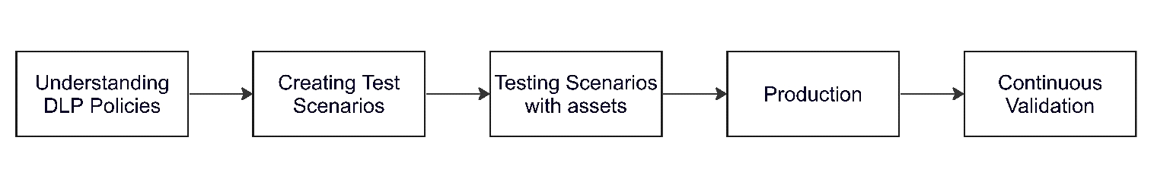
Figure 4.3.1: steps to implement Continuous DLP Security Controls Validation
- Understanding DLP Policies:
- During the initiation of the project, it is essential to comprehend the DLP policies against which test cases are being built.
- Understanding how DLP works across different channels in the organization and the policies implemented helps in creating more effective test cases.
- Different channels implement controls in various ways, affecting the data they inspect and the barriers they establish at different levels. Creating test Case scenarios:

- Creating Test Case Scenarios
- When creating test cases, it is vital to ensure that the correct DLP control is being targeted; otherwise, an unintended control may perform the action, leaving the intended tool untested.
- Test cases must be crafted with caution, especially since they will run in an automated fashion, and should yield expected results.
- Each test case must include detailed documentation to ensure clarity for both technical and non-technical stakeholders.
- Testing Scenarios with Assets:
- Testing these cases allows developers to check all fields involved, rectifying any mistakes before deployment.
- This phase may reveal gaps in DLP policy that need addressing, identified during the test run.
- Generally, testing is performed with one or two assets, which may change during the production phase.
- Production:
- In this phase, test cases are deployed into production.
- A larger set of assets is used to verify compliance against geo-based policies if applicable.
- Relevant teams should be informed about the test runs, as they may trigger false positive security events.
- This phase provides true results on the effectiveness of the DLP controls in place organization wide.
- Continuous Validation:
- Test cases that have successfully run in the production phase are placed into "Scheduled Mode" for continuous validation.
- These test cases execute at defined intervals, adjustable based on team feedback on frequency.
- An automatic incident creation feature is enabled to trigger alerts when a test case fails, indicating a DLP control has failed to prevent data exfiltration.
- Incidents are routed to the Incident Response Team (IRT), ensuring the control owner is informed and that necessary measures are taken to address vulnerabilities promptly.
- This phase also assists leadership in understanding the reasons behind any incidents, such as downtime of the DLP tool, ensuring accountability with vendors.Role of Wazuh:
- Integration: Wazuh will be integrated throughout each phase to monitor events, analyze logs, and detect anomalies related to data loss prevention.
- Automation: Wazuh's capabilities will automate the incident response process, enabling real-time alerts when test cases fail.
- Reporting: Utilize Wazuh’s reporting features to provide insights into the performance of DLP controls, aiding in continuous improvement.
The below image shows a detailed view of a test case. It contains technical information about the test case including all the tests in the assessments, results, schedule, reports, teams, and notification. Each subsection has features to compliment more features.
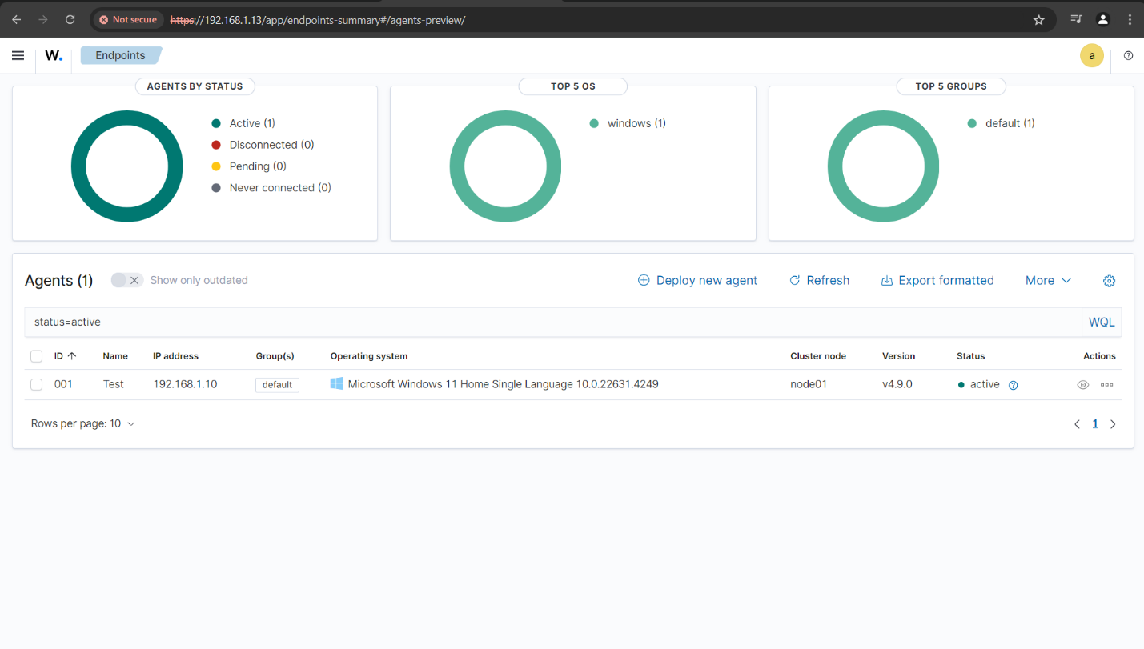
It also detects all the logs which can be further analysis.
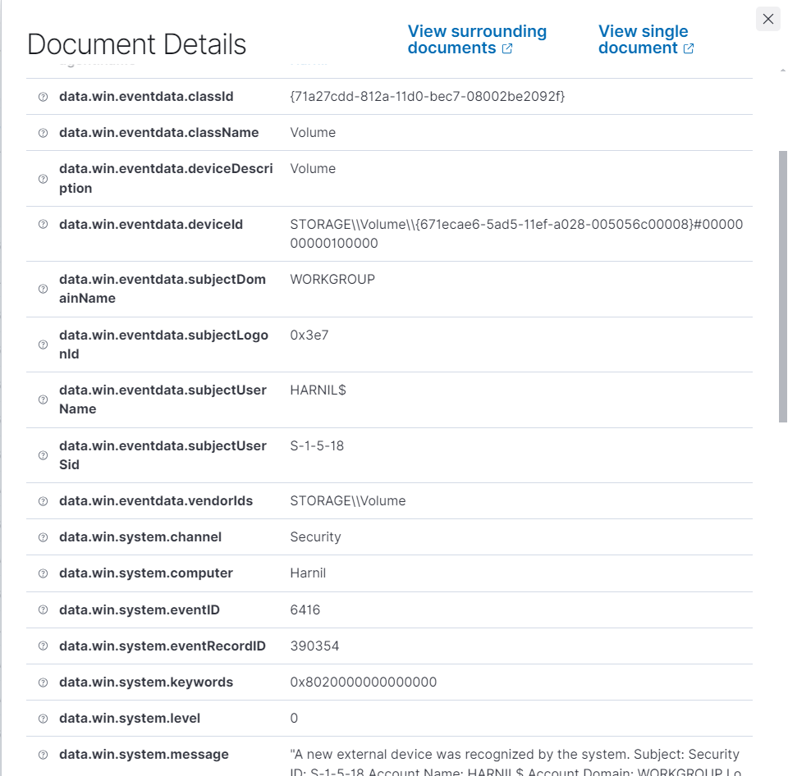

Validation:
To run the test cases on the assets, it is necessary to install the testing tool’s agent on it. This page allows developers to download the agent in accordance with the Assets configuration. It allows Windows, MacOS & Linux. It also has options for different processors and build type.
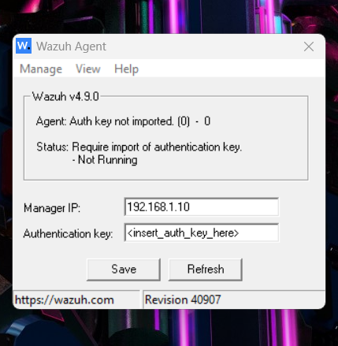

4.4 IMPLEMENTATION
4.4.1 Implementation environment and laboratory setup
Installation of Wazuh OVA
Prerequisites
- Virtualization Software: Ensure you have a hypervisor installed, such as VMware Workstation, VMware ESXi, or Oracle VirtualBox.
- Wazuh OVA File: Download the latest Wazuh OVA file from the Wazuh website.
Steps to Install Wazuh OVA
- Import the OVA File:
  - For VMware:
    - Open VMware Workstation or ESXi.
    - Go to File > Deploy OVF Template.
    - Browse to the location of the downloaded Wazuh OVA file and select it.
    - Click Next and follow the prompts to complete the deployment.
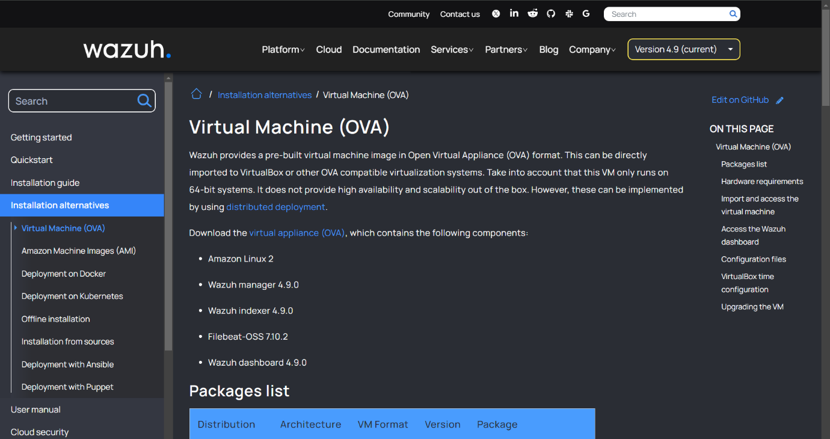
  - For VirtualBox:
    - Open VirtualBox.
    - Click on File > Import Appliance.
    - Browse to the Wazuh OVA file and select it.
    - Click Next, review the settings, and click Import.
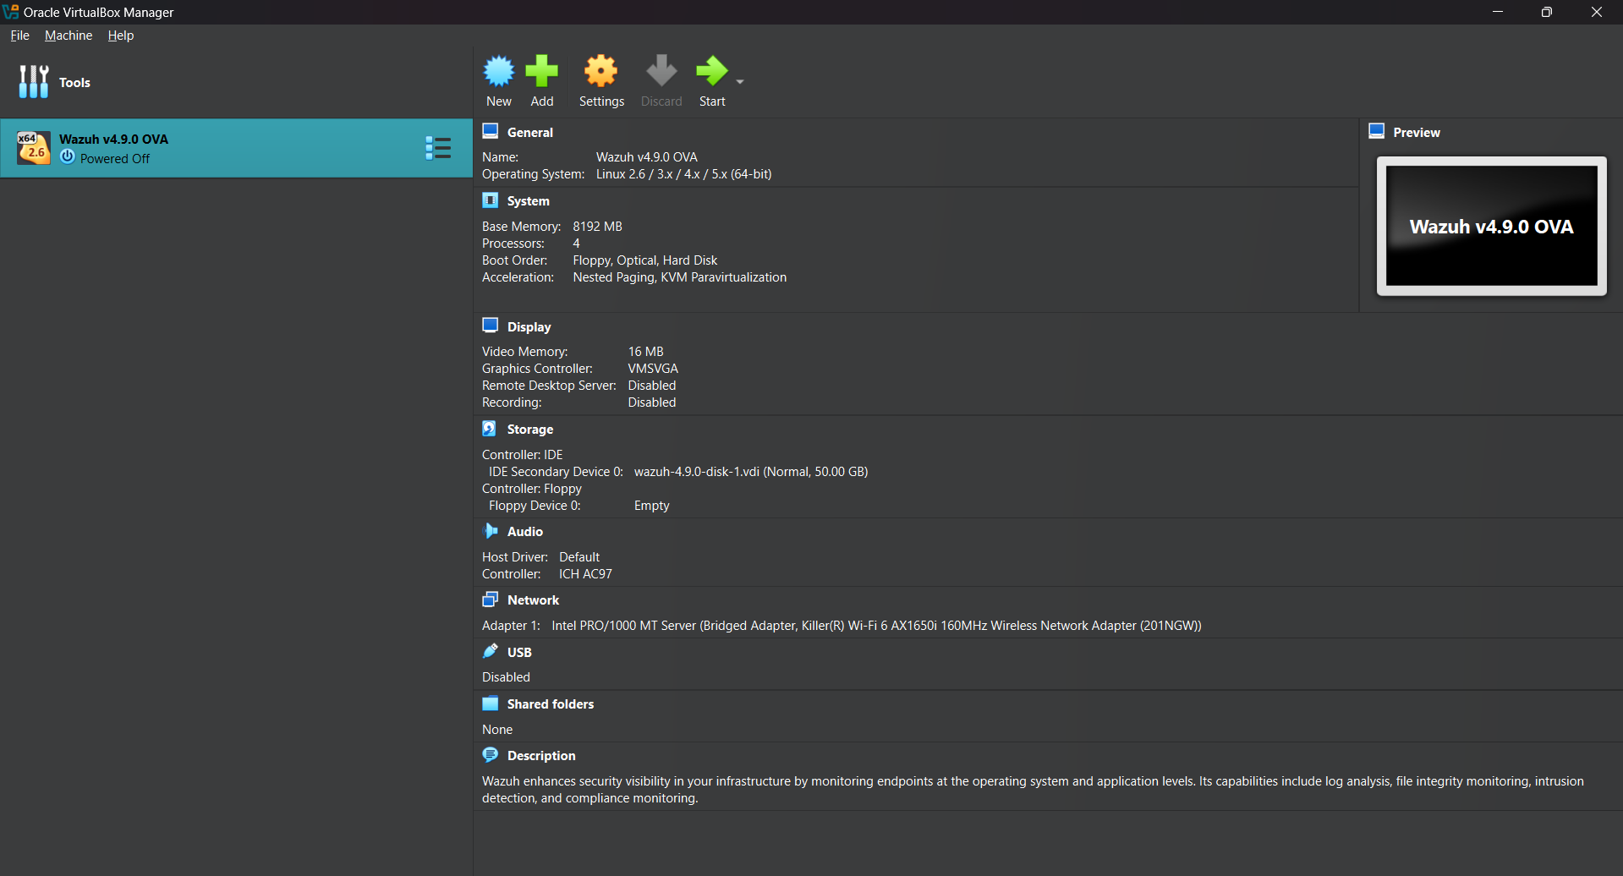
- Configure the Virtual Machine:
  - After importing, configure the virtual machine settings, if necessary:
    - Network Settings: Ensure the VM is connected to a network (NAT, Bridged, etc.) based on your requirements.
    - Resources: Allocate sufficient CPU, RAM, and disk space according to your needs.
- Start the Virtual Machine:
  - Power on the virtual machine.
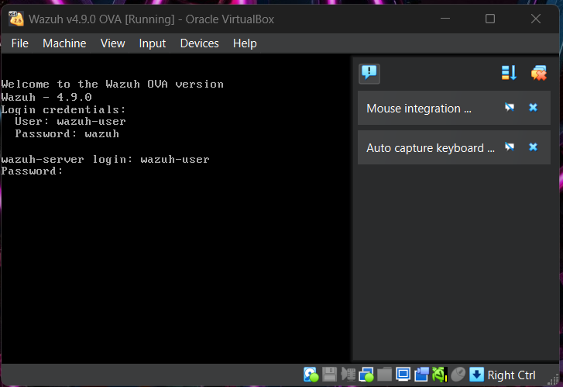

- Access the Wazuh Web Interface:
- Once the VM boots up, it will display its IP address.
(give command ip a)
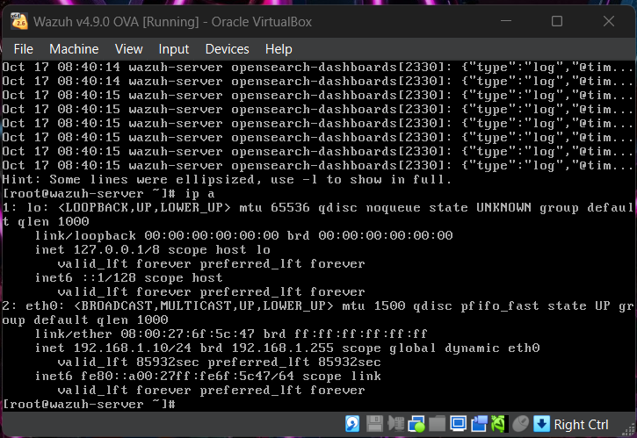

- Now after login in wazuh we need root access for further steps so using (sudo -i) command go to the root access.
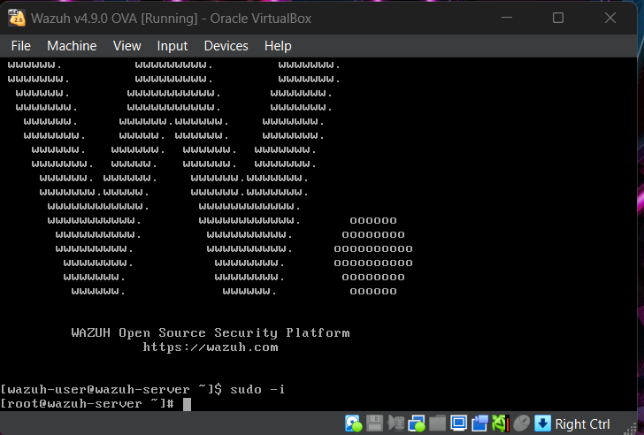

- for wazuh manager, dashboard and indexer write following commands which are shown in below image.
- Then check the current status of wazuh-dashboard.
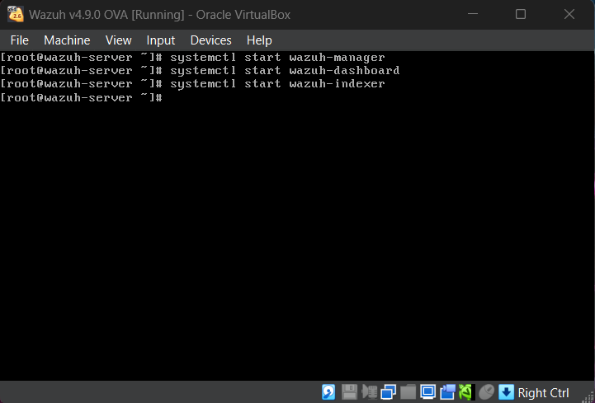

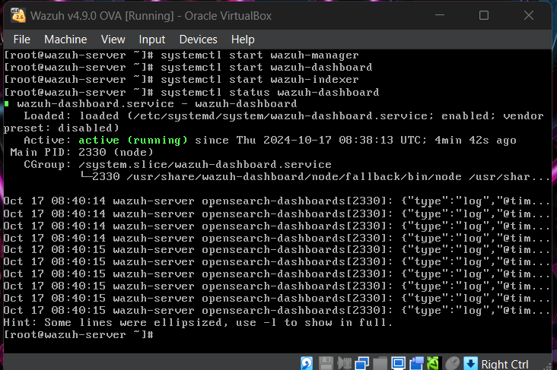
- Open a web browser and enter the IP address to access the Wazuh web interface.
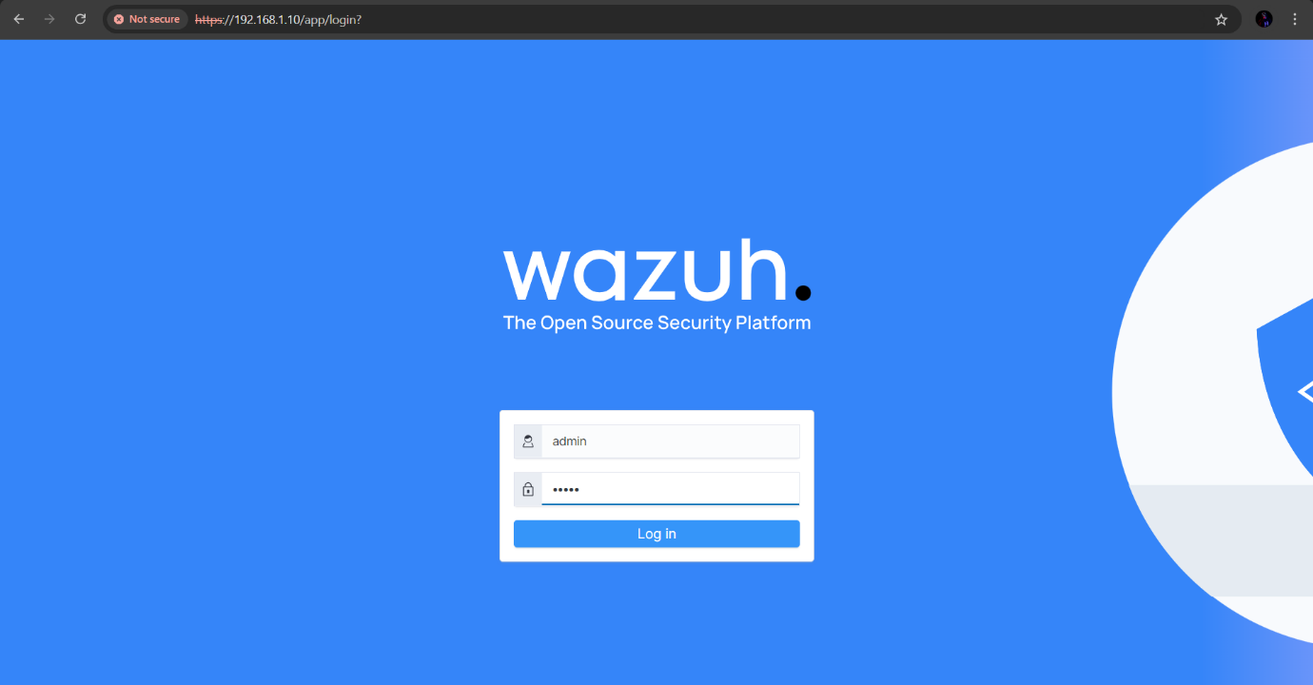

- Install Wazuh Agents:
- we need to add agent (endpoint) so we need to download user agent
- For this I am going to download user agent for windows. (https://packages.wazuh.com/4.x/windows/wazuh-agent-4.9.0-1.msi)
- Then install it on the device.


4.5.2 Integration and testing.
1. follow this step on the endpoint device, first go to the local security policy then, advance APC => Detailed Tracking => Audit PNP Activity make sure it is successful.
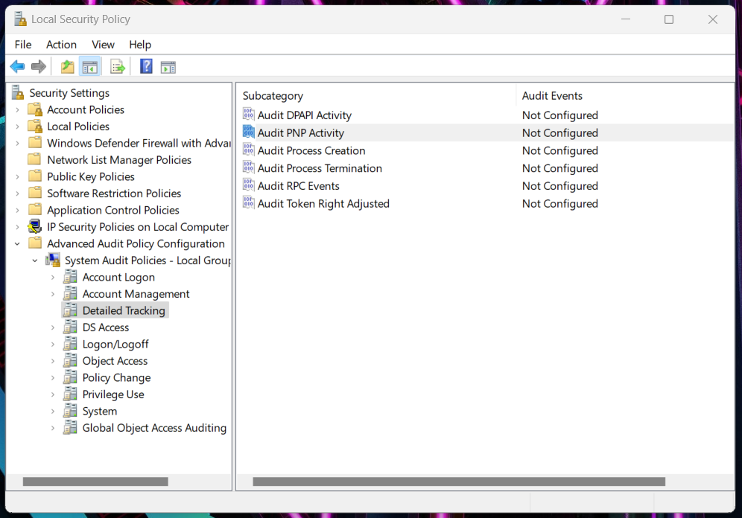

Now your device can collect logs in event Viewer when USB will attach.
If you can get logs of PNP on event viewer follow these steps
In the local security policy, local policy then audit policy and make audit process tracking to success and failure.
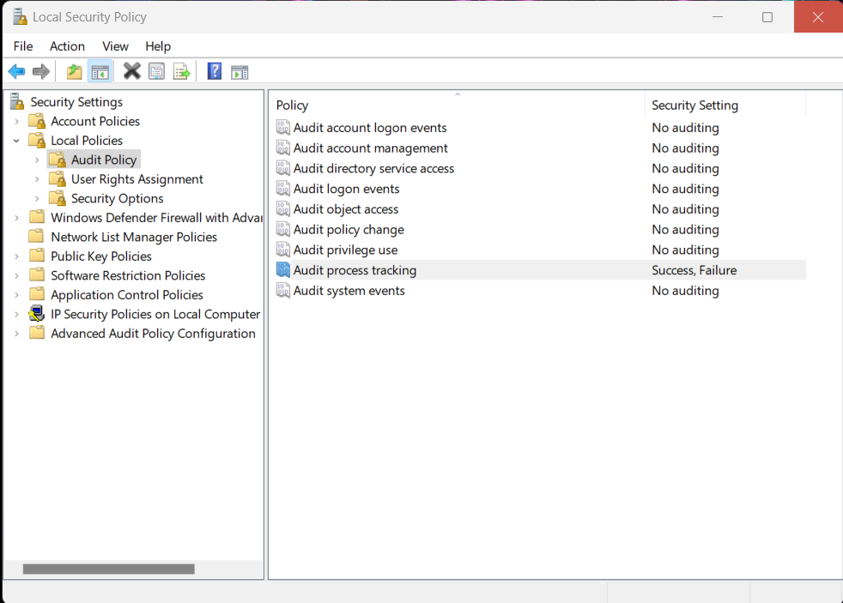

2. Now go to wazuh server (vm) and follow command
(nano /var/ossec/etc/rules/local_rules.xml)
Now write rules there.
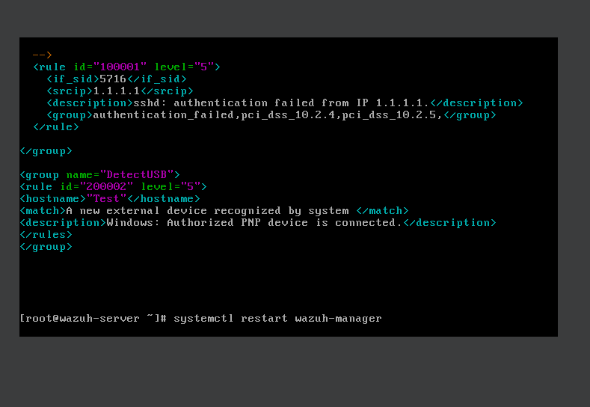
3. After saving the rule restart wazuh manager. Dashboard and indexer.
Then refresh the wazuh dashboard.
Step-4 now connects any USB drive to an endpoint device.
We will get logs on to event viewers of the endpoint system as well as on wazuh dashboard.
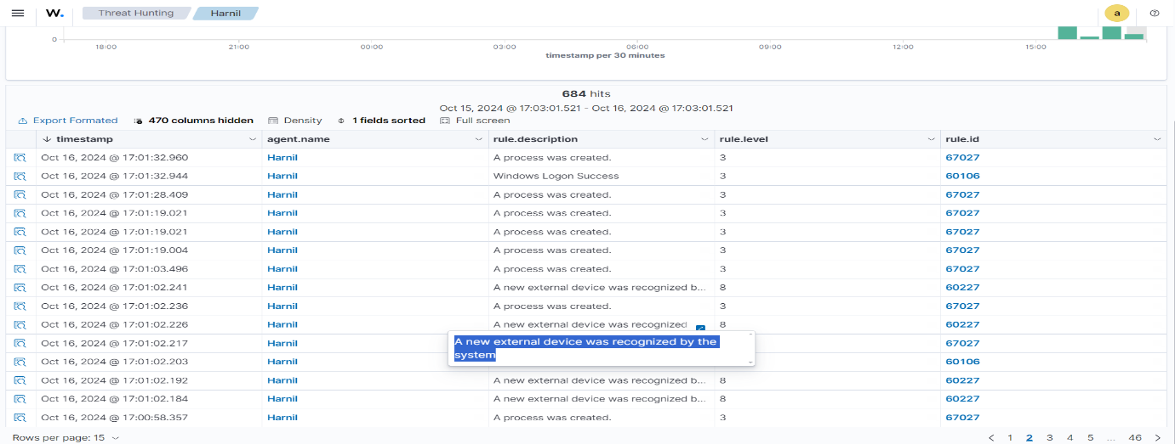


5.Outcomes
- Improved Data Security:
  - Enhanced protection of sensitive data against unauthorized access, loss, or breaches.
  - Implementation of effective DLP policies and practices will reduce the risk of data exfiltration.
- Effective Monitoring and Detection:
  - Continuous monitoring of data flows, enabling quick detection of suspicious activities.
  - Wazuh will provide real-time alerts on potential data breaches or policy violations, allowing for immediate response.
- Increased Compliance:
  - The project will help ensure compliance with data protection regulations (e.g., GDPR, HIPAA) by implementing necessary DLP controls.
  - Regular audits and reporting features in Wazuh will facilitate compliance verification.
- Enhanced Employee Awareness:
  - Training programs and awareness campaigns will educate employees about data security best practices and the importance of DLP measures.
  - Increased employee engagement in protecting sensitive data.
- Robust Incident Response:
  - Improved incident response capabilities through automated alerts and defined workflows for handling data breaches.
  - Establishment of a clear protocol for managing and remediating security incidents related to data loss.
- Data Classification and Management:
  - Implementation of data discovery and classification processes to identify and categorize sensitive data effectively.
  - Better management of data assets through defined access controls and encryption measures.
- Customizable DLP Solutions:
  - The ability to tailor DLP rules and policies in Wazuh based on the organization’s specific needs and regulatory requirements.
  - Flexibility in adapting to new threats or changes in data handling practices.
- Ongoing Improvement and Alerting:
  - Continuous addition of alerts for various data handling methods (e.g., HTTP, email, USB) to enhance monitoring capabilities.
  - Regular updates to DLP rules and policies in Wazuh to cover emerging threats and new data transfer methods.
  - Development of new test cases and rules to ensure comprehensive coverage across all potential data loss vectors, enhancing overall data protection.
- Long-Term Risk Mitigation:
  - Reduction in the likelihood of data breaches, leading to lower potential costs related to data loss incidents (e.g., fines, legal fees, reputational damage).
  - Establishing a culture of security within the organization that prioritizes data protection.
- Scalability:
  - The DLP framework can be easily scaled to accommodate future growth or changes in the organization’s data management practices.
Ability to add new data sources, policies, and monitoring tools as needed.
6. Proposed Work & Outcomes
In Technical Propose we use DLP tool configuration, DLP policies and PowerShell for more improve in data loss prevention.
And also use tolls and technology tools like testing tool, web DLP tool for web app and email DLP tool for email for email data loss prevention.

In this project, we will configure DLP tools, establish comprehensive DLP policies, and utilize PowerShell to enhance our data loss prevention efforts. We will also employ a variety of tools and technologies, including testing tools, web DLP tools for web applications, and email DLP tools specifically designed for protecting email communications.
Email DLP solutions typically encompass features such as content screening and scanning, data discovery and classification, access restrictions, and encryption. Implementing effective email DLP solutions will enable organizations to comply with legal obligations and avoid costly data breaches that could damage their reputation. By ensuring that sensitive data is secured during email communications, organizations can significantly mitigate the risk of data loss.

Outcomes
- Improved Data Security:
  - Enhanced protection of sensitive data against unauthorized access, loss, or breaches.
  - Implementation of effective DLP policies and practices will reduce the risk of data exfiltration.
- Effective Monitoring and Detection:
  - Continuous monitoring of data flows, enabling quick detection of suspicious activities.
  - Wazuh will provide real-time alerts on potential data breaches or policy violations, allowing for immediate response.
- Increased Compliance:
  - The project will help ensure compliance with data protection regulations (e.g., GDPR, HIPAA) by implementing necessary DLP controls.
  - Regular audits and reporting features in Wazuh will facilitate compliance verification.
- Enhanced Employee Awareness:
  - Training programs and awareness campaigns will educate employees about data security best practices and the importance of DLP measures.
  - Increased employee engagement in protecting sensitive data.
- Robust Incident Response:
  - Improved incident response capabilities through automated alerts and defined workflows for handling data breaches.
  - Establishment of a clear protocol for managing and remediating security incidents related to data loss.
- Data Classification and Management:
  - Implementation of data discovery and classification processes to identify and categorize sensitive data effectively.
  - Better management of data assets through defined access controls and encryption measures.
- Customizable DLP Solutions:
  - The ability to tailor DLP rules and policies in Wazuh based on the organization’s specific needs and regulatory requirements.
  - Flexibility in adapting to new threats or changes in data handling practices.
- Ongoing Improvement and Alerting:
  - Continuous addition of alerts for various data handling methods (e.g., HTTP, email, USB) to enhance monitoring capabilities.
  - Regular updates to DLP rules and policies in Wazuh to cover emerging threats and new data transfer methods.
  - Development of new test cases and rules to ensure comprehensive coverage across all potential data loss vectors, enhancing overall data protection.
- Long-Term Risk Mitigation:
  - Reduction in the likelihood of data breaches, leading to lower potential costs related to data loss incidents (e.g., fines, legal fees, reputational damage).
  - Establishing a culture of security within the organization that prioritizes data protection.
- Scalability:
  - The DLP framework can be easily scaled to accommodate future growth or changes in the organization’s data management practices.
Ability to add new data sources, policies, and monitoring tools as needed.

7.Diagram (UML)/Wireframe

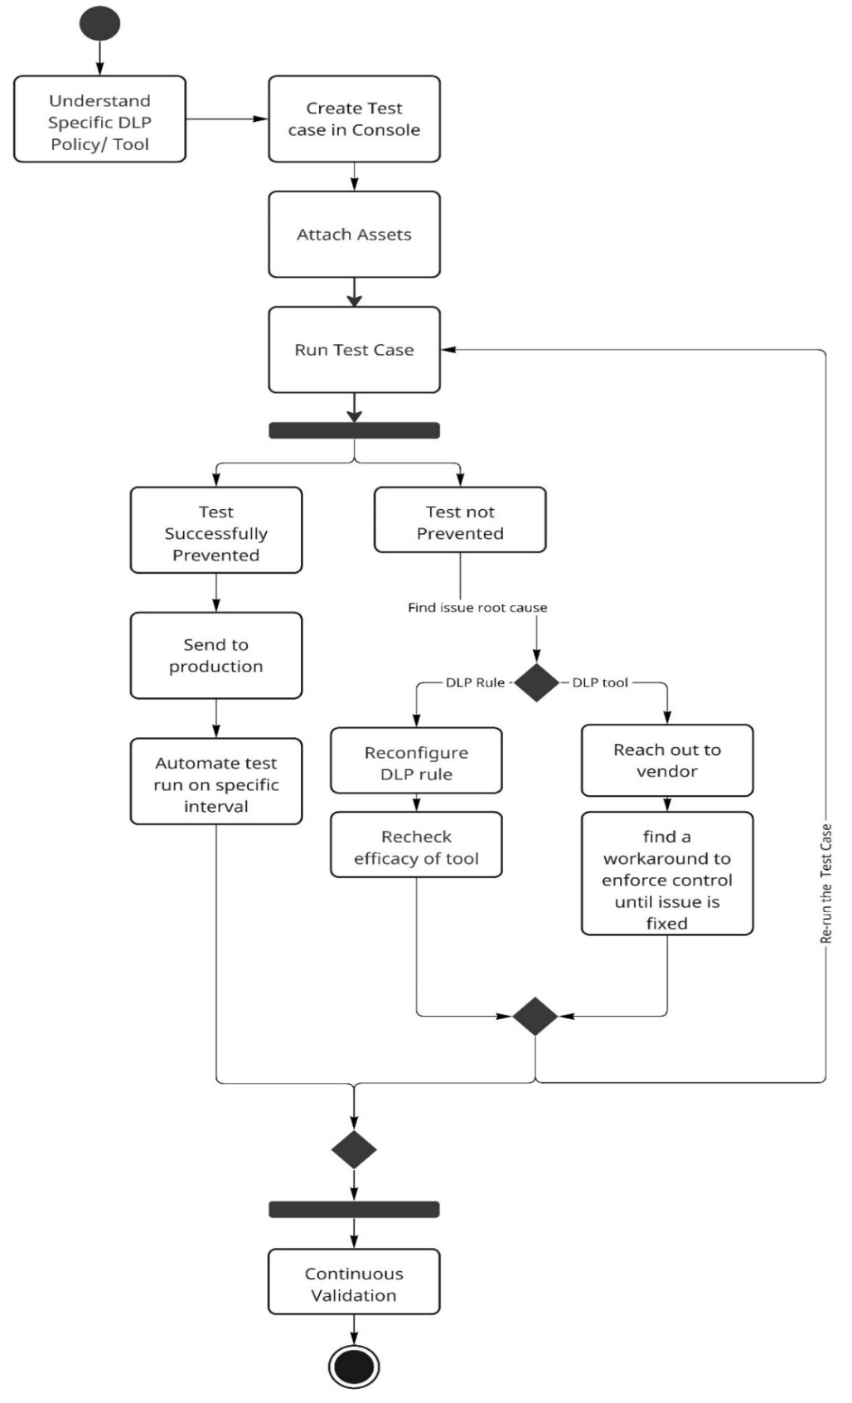
8.Timeline Chart

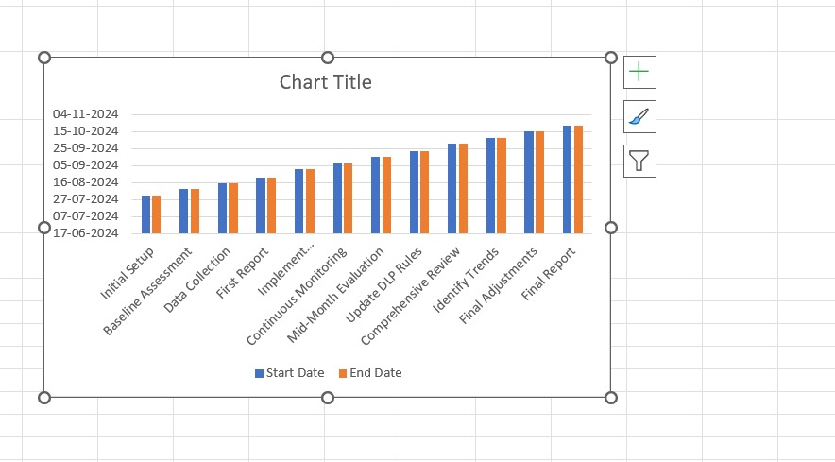

9.Future Work
Data Loss Prevention is too broad a task to be satisfied with a few tests. Constraints such as the ability to act as an individual with resources and equipment need to be addressed. It is not possible to create a separate test case for each file type. Although it is important to ensure that important data is found in these files. This refers to the fact that many test cases cannot be forced to execute periodically but must be tested at least once. For example, it is not possible to create different test cases based on unattended devices. While necessary, it is highly unlikely that you will acquire and keep unused devices on an organization’s network solely for its own sake.
The agent of the test instrument acts as a machine and not a human. This poses a serious problem for test cases based on pure scripts. There is no solution to this problem yet. Workarounds should be explored for any such tests.
Some programs are deliberately excluded to ensure that continuity of operation is compromised. It must ensure that those policies intended for effective implementation are not exploited, thereby ensuring that the responsible instruments understand the difference between the two. If the controls are not used directly for this information, they can be used in other ways.

10.Conclusion
Data Loss Prevention is a very concerned and trending aspect of Cyber Security and Data Security amongst organizations currently. This project holds significant value for an organization to make sure the policies that it has created to secure its Sensitive Data is in place and working as expected from it. It can be concluded here that the testing of these DLP policies must not end here. Data has huge value and specially if it is Intellectual Property of an organization. Thus, this project must be carried forward by adding more test cases with different test files and various extensions to include every probable possibility of data exfiltration to reduce Data Exfiltration possibility.
Also In conclusion, the project can be understood as a huge accomplishment towards data security and proactive approach for the same. Although it does need more test cases to make sure every corner is covered so that there is least probability of data breach. Continuous development concept helps the project is providing more fruit which will also make sure that new test cases must work hand-in-hand with the updates that are made in policies that come as a demand from organization and Data Security Management.

11.Reference
[1]
B. Hauer, “Data and Information Leakage Prevention Within the Scope of Information Security,” IEEE Access, vol. 3, pp. 2554–2565, 2015, doi: 10.1109/ACCESS.2015.2506185.
[2]
R. S. Kadu and V. B. Gadicha, “Review on Seuring Data by Using Data Leakage Prevention and Detection,” vol. 5, no. 5.
[3]
G. Katz, Y. Elovici, and B. Shapira, “CoBAn: A context based model for data leakage prevention,” Information sciences, vol. 262, pp. 137–158, 2014.
[4]
M. Nicho and A. Advani, “A Data Centric Security Cycle Model for Data Loss Prevention of Custodial Data and Company Intellectual Property,” 2012.
[5]
C. Tikkinen-Piri, A. Rohunen, and J. Markkula, “EU General Data Protection Regulation: Changes and implications for personal data collecting companies,” Computer Law & Security Review, vol. 34, no. 1, pp. 134–153, Feb. 2018, doi: 10.1016/j.clsr.2017.05.015.
[6]
J. Zhang, B. Chen, Y. Zhao, X. Cheng, and F. Hu, “Data Security and Privacy-Preserving in Edge Computing Paradigm: Survey and Open Issues,” IEEE Access, vol. 6, pp. 18209–18237, 2018, doi: 10.1109/ACCESS.2018.2820162.
[7]
S. Alneyadi, E. Sithirasenan, and V. Muthukkumarasamy, “A survey on data leakage prevention systems,” Journal of Network and Computer Applications, vol. 62, pp. 137–152, Feb. 2016, doi: 10.1016/j.jnca.2016.01.008.
[8]
E. De Rademaeker, G. Suter, H. J. Pasman, and B. Fabiano, “A review of the past, present and future of the European loss prevention and safety promotion in the process industries,” Process Safety and Environmental Protection, vol. 92, no. 4, pp. 280–291, Jul. 2014, doi: 10.1016/j.psep.2014.03.007.
[9]
“DATA LEAKAGE PREVENTION AND DETECTION IN DIGITAL CONFIGURATIONS: А SURVEY | ENVIRONMENT. TECHNOLOGIES. RESOURCES. Proceedings of the International Scientific and Practical Conference.” Accessed: Oct. 18, 2024. [Online]. Available: https://journals.ru.lv/index.php/ETR/article/view/8045
[10]
“Federal Data Breach Prevention: A Phenomenological Study of Experts’ Strategies - ProQuest.” Accessed: Oct. 18, 2024. [Online]. Available: https://www.proquest.com/openview/340bbf0d9f1eaea3de14a98c304e31d0/1?pq-origsite=gscholar&cbl=18750&diss=y

